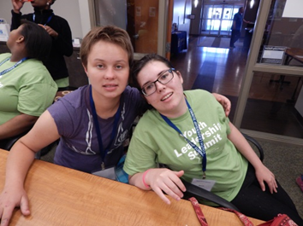
Summer Programs
2022!

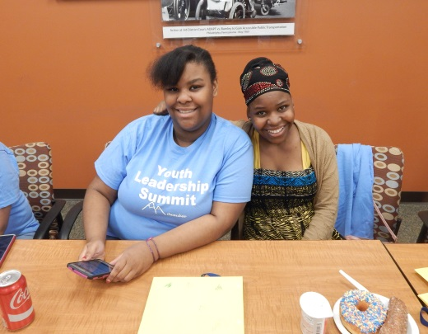
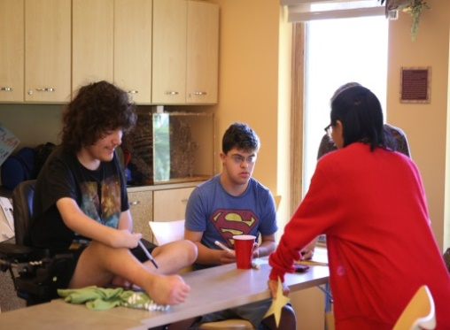

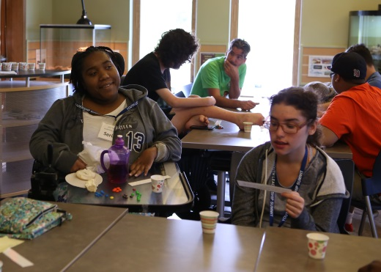
Programs for youth and adults with disabilities
All sessions are FREE

Programs at a Glance

Social Skills
This workshop will take a closer look at social skills, how to move past comfort zones, understand social cues, and focus in on appropriate social media skills. (Youth and adults with disabilities)
When: June 7th – June 28th (Tuesdays), 1:00pm – 2:30 pm

Stress Reduction Tips & Tools
Want to know how stress affects your physical and mental well-being. In this workshop, we will explore possible ways to reduce and manage stress. After one introductory session, each session will take a deeper look into specific tips for reducing stress. At the end of the 8-week workshop, you will have tips and tools to use when stressed in the future.

When: June 9th – July 28th (Thursdays) 4:30pm – 6:00pm

Gardening Club
Explore your relationship with nature by participating in outdoor green activities while utilizing accessible gardening methods. Activities will include: design and maintenance of raised garden beds, planting and caring for various varieties of greenery and developing an understanding of environmental consciousness. Come join us to help create something living and new. (Youth and adults with disabilities)
When: June 10th – August 5th (every other Friday), 1:00pm – 2:00pm

Take a Hike Club
Explore your relationship with nature by joining our Hiking Club for youth and adults with disabilities. This group will promote health and nature appreciation by getting outside and exploring new destinations at Milwaukee metro area parks and recreational areas. Each week we will meet at a different accessible destination to enjoy the fresh air with new friends. Each participant will receive a hiking themed back pack filled with hiking supplies such as a camera, water bottle, binoculars and nature based activities.
When: June 14th – August 2nd (Tuesdays), 3:00pm – 5:00pm
*Weather permitting
First hike will be at the Lakefront, at that time a schedule will be distributed to the group.

“What is Advocacy?” Making a Difference Locally
These one-day sessions will be packed with information to learn how to be an effective self-advocate, how to connect with your local legislators, tips on assertive communication, and how meaningful systemic change can be impacted by our efforts. (youth and adults with disabilities)
Where: Grafton
When: June 16th, 9:00am – 12:00pm

Where: Waukesha
When: June 23rd, 9:00am – 12:00pm

If You Cook, They Come
This workshop will discuss interesting and delicious topics such as how to create a weekly meal plan, how to get to and successfully navigate the grocery store, how to shop for deals, and how to store and prepare food properly. Other food resource strategies such as enrolling in FoodShare, attending Farmer’s Markets, cooking in bulk, and using seasonal produce to save on costs will also be discussed. Participants will be encouraged to learn how to safely and effectively use basic cooking equipment will be given the opportunity to practice their skills by cooking actual meals. (Youth and adults with disabilities)
When: June 20th – August 1st (every other Monday), 2:00pm – 3:30pm

Art Workshop
In this Art workshop we will be creating works with different artistic media to learn how to tell our stories as people with disabilities. We will explore the different ways art has been used in advocacy and build upon these examples to create personal artworks throughout the workshop. Our goal is for participants to gain confidence in advocating for themselves, whether personally or systems wide by developing a sense of self-agency and community connection through the creation of expressive projects. (Youth and adults with disabilities)
When: June 22nd – July 20th (Wednesdays), 3:00pm – 4:30pm

Youth Leadership Summit
From planning for life after high school to learning how to advocate for oneself and making connections with other youth with disabilities in a fun and supportive setting, the Youth Leadership Summit is a great way to spend a week of the summer break.
By Application ONLY!
When: June 27th – July 1st, 10:00am – 4:00pm
Lunch included

Making Proud Choices
This is a 4 day workshop series highlighting sexuality education for high school and middle school students with disabilities. The workshop includes issues of sexual health, preventing teen pregnancy, STD, and HIV. Students with disabilities don’t always receive sexuality education in high school or they don’t receive it in a way that is accessible to them. Our goal is to empower adolescents with disabilities to make healthy sexual decisions that will significantly decrease their risk of becoming involved in unintended pregnancies and becoming infected with STD’s. The curriculum stresses that abstinence is the most effective way to eliminate these risks while realizing that many adolescents do not choose abstinence. Consent, boundaries, safety, and how to recognize healthy vs. unhealthy relationships are also discussed. (Youth with disabilities)
When: July 11th – July 14th, 2:00pm – 3:30pm

Home Management
These one-day sessions will provide interactive educational opportunities to learn valuable new home management skills. Join us to learn how to do chores, use important safety tips, cook and store food wisely, and the importance of being responsible for your own space. (Youth and adults with disabilities)
Where: Grafton
When: July 22nd, 12:30pm – 3:00pm

Where: Waukesha
When: August 19th, 12:30pm – 3:00pm

Peer Support Mentor Volunteer Training
Come find out more about becoming a volunteer peer mentor for Independence First! Learn about our mission and philosophy and empowering other people with disabilities! (Youth and adults with disabilities)
When: July 25th – July 27th, 10:00 am – 12:00 pm

Adaptive Telephone Equipment (TEPP) Workshop
Want to be able to communicate more independently? Have difficulty hearing on the phone or seeing the buttons? Join us to us to learn more about available adaptive telecommunications options and funding resources and explore exciting new assistive technology!
When: July 27th, 9:00am – 11:30am

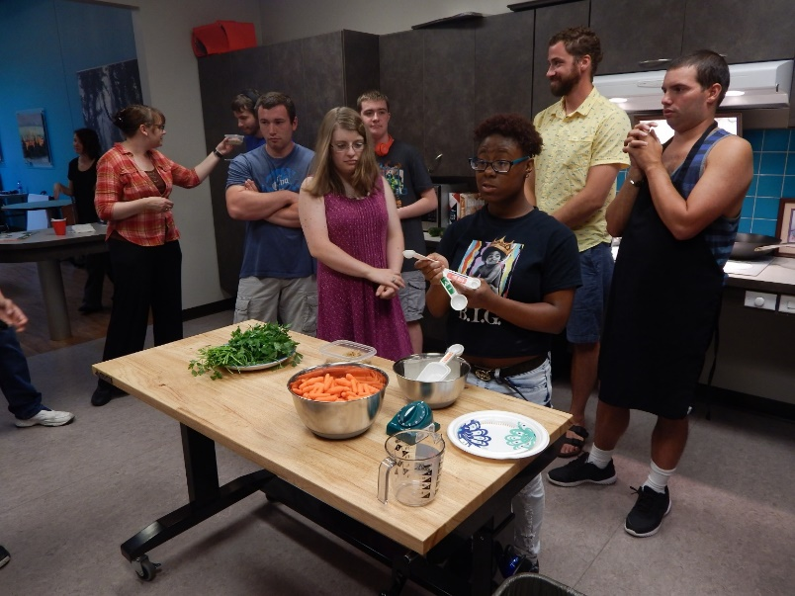

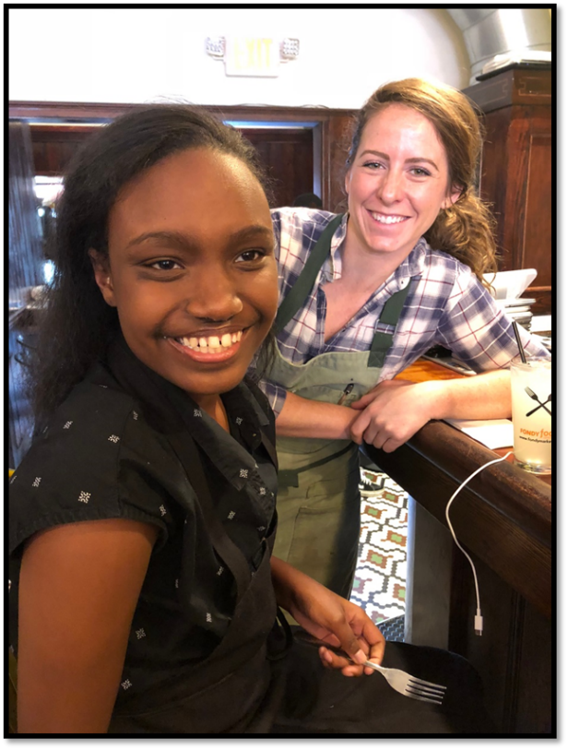

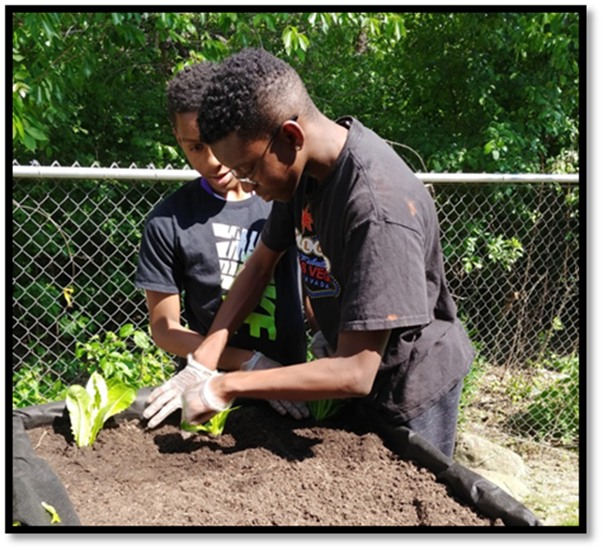

Workshop Schedule
Dates | Time | Workshop
Jun. 7 – Jun. 28  (Tuesdays) | 1:00 pm – 2:30 pm | Social Skills
Jun. 9 – Jul. 28 | 4:30 pm – 6:00 pm | Stress Reduction Tips & Tools
Jun. 10th – Aug. 5th  (Every other Friday) | 1:00 pm – 2:00 pm | Gardening Club
Jun. 14 – Aug. 2  (Tuesdays) | 3:00 pm – 5:00pm | Take a Hike Club
Jun. 16 (Grafton)  Jun. 23 (Waukesha) | 9:00 am – 12:00pm | “What is Advocacy? Making a difference locally”
Jun. 20th – Aug. 1  (Every other Monday) | 2:00 pm – 3:30 pm | IF You Cook, They Come
Jun. 22 – Jul. 20  (Wednesdays) | 3:00 pm – 4:30 pm | Art Workshop
Jun. 27 – Jul. 1 | 10:00 am – 4:00 pm | Youth Leadership Summit
Jul. 11 – Jul. 14 | 2:00 pm – 3:30 pm | Making Proud Choices
Jul. 22 (Grafton)  Aug. 19 (Waukesha) | 12:30 pm – 3:00 pm | Home Management
Jul. 25 – Jul. 27 | 10:00 am – 12:00 pm | Peer Support Mentor Volunteer Training
July 27 | 9:00 am -11:30 am | Adaptive Telephone Equipment (TEPP) Workshop
How to Register
To register for workshops or group, call 414-226-8375 V/Relay and leave your name, phone number and the workshops or groups that you would like to attend.

Reasonable Accommodations Independence First is committed to providing the highest degree of accessibility when offering agency-sponsored events. Please notify Gerald Hay at 414-226-8331 V/Relay or ghay@independencefirst.org with your disability-related accommodation requests two weeks before the start date of the workshop or group. We will do our best to honor accommodation requests made after this date. | Environmental Chemical Sensitivities  For the safety and comfort of those with chemical and environmental sensitivities, Independence First requests that when attending agency-sponsored events, please refrain from using any perfumed products such as scented soaps, deodorants, perfumes, colognes and heavily scented fabric softeners. To maintain a smoke-free environment, please also refrain from smoking in paths of travel and doorways.

